Initial Project Document

Project Narrative:
ThinkNav Drone is a thinking quadcopter that navigates using visual learning to identify waypoints and obstacles and navigates through them with the use of spoken language interpreted through machine learning software. By utilizing common spoken instructions, the drone can understand the meaning of the spoken word, and interpret those words as instructions to navigate autonomously; A visual learning framework is used to allow the drone to interpret visual stimuli for use of positioning and navigation.
This project, being sponsored, has its own set of design goals set out to be accomplished by our team. The goals put forward to us initially that have to be met are as follows: The robot can perceive the scene, understand and ground language, and act in the real world environment. In addition a number of subgoals were set out for us. Namely the implementation of a state-of-art VLN agent. By utilizing all of the resources set out, we are meant to achieve a success rate of at least within 3 meters of the target area. In addition a secondary metric of our success relies upon our navigation error, which is the distance between target viewpoint T and the agent's stopping position. As well we are measured by our success rate weighted by path length, which considers error relative to how long the agent has gone on. The design goals are purely for the software agent, not implemented yet into the Drone. Once we are to transfer that agent into a drone, we are to complete two physical evaluations, one with and one without map. We are then to be judged upon the differences in visual domain and the actors' space. This also brings up physical errors we are to be aware of that might not crop up in a purely digital environment.
The further goal of this project is to design a reasonably priced, replicable, and fully independent drone that can use Vision and Language Navigation to pilot itself with the only input from a human being's spoken instructions. This technology could be useful for any sort of exploration of urban centers, as well as, if further developed, unmanned autonomous exploration. This technology shines through a bit more whenever it is considered that the “pilot” does not need to be fully engaged with the drone, freeing them up for more activity. Due to how we plan on using the drone in testing, as well as its possible use for exploration type activities, an extended battery lifetime is a design goal for this project. In addition, due to the drone not being piloted manually, a level of durability and protection on the drone to allow it to function even after minor incidents also remains a design goal. Finally, due to the brunt of the project relying on the software that interfaces with the hardware, it allows for the project to be replicated on, in theory, any drone with the proper standard of video capture, audio capture, and processing power; making it a replicable project.
The ThinkNav Drone system itself features: a microphone for audio capture, a video camera affixed to the drone to allow for navigation, a board capable of processing the amount of information require for the software to function, and the navigation drone itself, capable of lifting the load of the hardware affixed to it.

Software Block Diagram
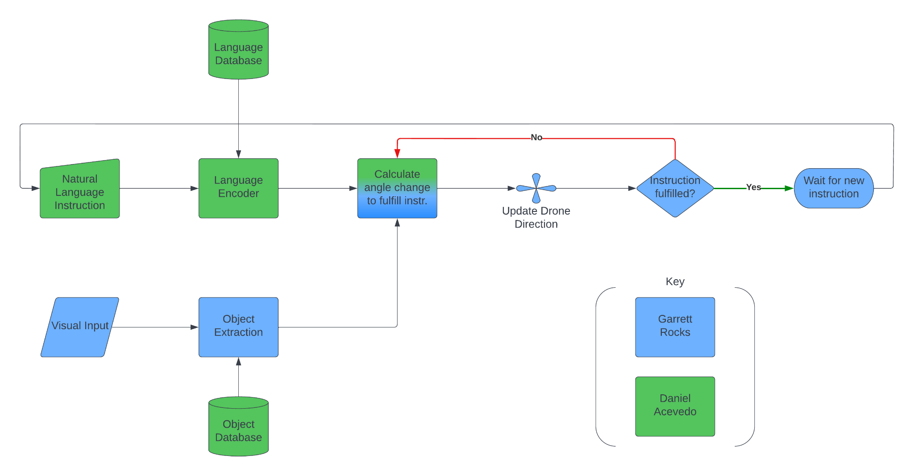
Fig. 1 - Software Block Diagram

This block diagram shows the flow from the input to the output of the drone system at a high level. The 2 inputs consist of the natural language instruction that is spoken to the drone by the operator, and the visual input from the camera and lidar altitude sensor. The output is the angle change that the drone needs to make in order to be oriented to complete its instruction. This output is connected to a loop that checks if the instruction given has been fulfilled, and if it has not, then it goes back to the inputs and creates a new output given the new location and orientation of the drone since it last calculated an output angle. This is why the loop is necessary, in order to make sure that the drone does not stop without completing its task.

The language encoder and object extraction steps will both be handled by neural networks. It is anticipated that these networks will be connected via an API to databases. The language encoder network takes as an input the audio of a given natural language command. The object extractor takes as an input the visual environment that the drone is in via camera. These will either be separate networks, or connected as a single network that will give an output of a single value, the angle change that the drone must make in order to move closer to the object which it is getting directed.

Electrical Diagram Block Diagram
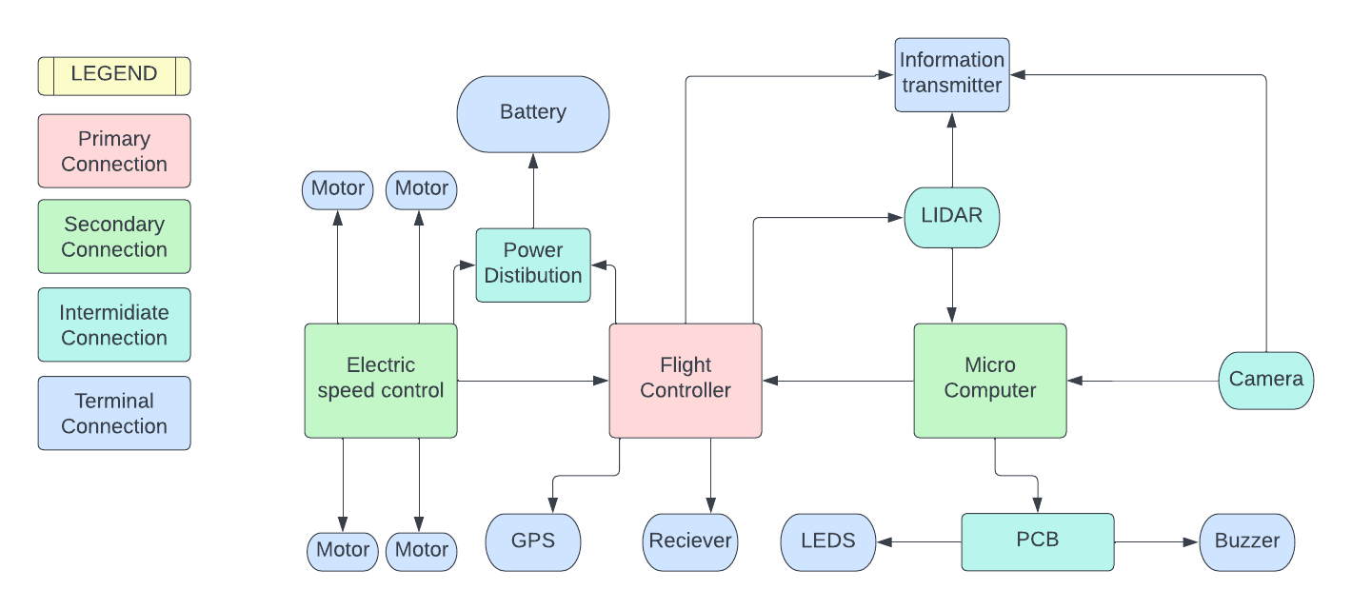
Fig. 2 - Electrical Block Diagram

For the electrical system for the drone it is centralized around the flight controller. The Flight controller, Micro computer, and electric speed control all go together in a stack in the middle of the frame. Branching out from those centralized units we have intermediate and terminal connections which link the main processing to the physical body which allows the drone to act on its own. The intermediate connections are the ones that are gateways to the transmitters which allow the processing units to control the drone. Some of these are the sensors like the LIDAR and camera which feed information to the micro computer. Being this is utilizing VLN it will need a relatively high processing power. This will be taken into account as we need the battery to accommodate the electrical load that it will take in mid flight.

Parts List Table

Parts | Purpose
Flight Controller | interprets input from the receiver, GPS module, battery monitor, IMU, and other onboard sensors.
Electric Speed Controller | An electronic speed controller or ESC is an electronic circuit with the purpose to vary an electric motor’s speed, and direction and possibly also acting as a dynamic brake.
Power Distribution Board | In charge of taking power from the battery and giving it to necessary components
Printed Circuit Board | This will be the connection between the buzzer and LEDs
Micro Computer | Used to process video and turn it into instructions for the flight controller
Receiver | Used to receive information from the base controller
LIDAR | A tool used on board that can constantly check the distance from objects
Video Transmitter | Takes the processed video information and sends it to the controller
Distance Transmitter | This takes the information given from the lidar and sends it to the Micro Computer
Buzzer | Used to give audio cues to give information such as dangerous distance
Frame | Holds all components.
GPS | Give real-time information on the location of the drone
LEDS | Give visual cues such as remaining battery life
Motor | Used to convert the electric power into flight
Propellers | Attached to motor
Vibration Dampeners | Used to keep boards safe from unwanted vibration
Wire Connectors | Used to tie everything together
Frame Kit | Holds all components
Camera | Gets visual information
Battery | Lithium polymer (LiPo) batteries offer the best combination of energy density, power density, and lifetime on the market.

Constraints

Constraint | Impact | Mitigation
Large budget - Though this project is sponsored, we want to reduce cost to the sponsor as much as possible. The drone and processors will be the main contributors to a large budget. | Low - since the project is sponsored, and it was known to be high cost up-front. | Cost effective solutions will be considered, design will only be to requirements and no more.
FAA & UCF Drone regulations - Our team needs to posess an FAA Part 107 License. | Low - obtaining this license is a standard process and the fee can be billed to the sponsor. | One of our team members will obtain an FAA Part 107 License and register the flight with UCF before our showcase at the end of SD2.
Environmental Concerns - The drone will use a battery and several processing elements which may contain hazardous chemicals or pose other dangers, like a Li-Ion battery’s danger of exploding. | Low - The probability of a dramatric failure of the battery or other chemical contamination of the environment is low. | Time and budget will be spent in researching and purchasing environmentally friendly options for the project hardware.
Supply Chain - With Covid-19 still affecting the global supply chain especially with certain electronics, some parts will be difficult to obtain on a reasonable timeline. | Medium - Certain surface mounted parts and other elements of PCB manufacturing willl potentially be a major timeline constraint. | Many elements of the project are highly available, and the elements that are not will be planned in advance to mitigate timeline concerns.
ECE Requirements - The project must contain major PCB design and satisy ECE’s other design requirements. | Medium - Many of these requirements are in line with our project design, but some of them wil require extra effort to incorporate. | During initial design phase an emphasis will be placed on fulfilling ECE requirements, especially PCB design.
Fig. 3 - List of Constraints
Requirement Specifications
”The system” refers to the drone and all the components such as the camera, mic, etc.
- The system shall not exceed the dimensions 24in x 24in x 24in
- The system shall not exceed 4 lbs in weight
- The system shall be able to ascend 10 feet
- The system shall be able to move 5mph
- The system shall have an input method for speech that the user can speak into
- The system shall have a method for converting the speech into instructions
- The system shall have a method to run these instructions
- The system shall have an API connecting the input devices to the drone
- The system shall have a battery life of 10 minutes
- The system shall have a camera that records 30+ fps
- The system shall be able to recognize objects using the camera and different datasets
- The system shall be able to carry out the instructions given
- The total cost shall not exceed $2000
- The system shall have a method for scanning it’s surrounding to look for desired item/obstacle

Milestones list
Milestone: | Tasked to: | Start Date: | End Date: | Status:
SENIOR DESIGN I
Familiarize ourselves with the project | Group 12 | 9/14/2022 | 9/21/2022 | Waiting for Ying Ma
Role assignments | Group 12 | 9/21/2022 | 9/28/2022 | Be familiar with project to do roles
Identify parts | Group 12 | 9/28/2022 | 10/19/2022 | Be familiar with project
Identify program side of project | Group 12 | 9/28/2022 | 10/19/2022 | Be familiar with project
Project Report | Group 12 | 9/28/2022 | 12/6/2022 | Start doing research on project
Initial Document  (Divide and Conquer) | Group 12 | 9/5/2022 | 9/16/2022 | Doing now
Updated  initial document | Group 12 | 9/16/2022 | 9/30/2022 | Need to finish initial document
First draft  (60 Pages) | Group 12 | 9/30/2022 | 11/4/2022 | Once we start research
Final draft  (100 Pages) | Group 12 | 11/4/2022 | 11/18/2022 | Need to finish first draft
Final document | Group 12 | 11/18/2022 | 12/6/2022 | Once we start research
Research, Documentation, and Design
Drone | Daniel Ab/Vinnie
Flight Parts | Daniel Ab/Vinnie | 9/16/22 | 11/24/2022 | TBD
Flight Controller | Daniel Ab/Vinnie | 9/16/22 | 11/24/2022 | TBD
MCU | Daniel Ab/Vinnie | 9/16/22 | 11/24/2022 | TBD
Integrated Sensors | Daniel Ab/Vinnie | 9/16/22 | 11/24/2022 | TBD
Approved BOM by Ying Ma | Group 12 | 9/16/22 | 11/24/2022 | TBD
Order Parts | Daniel Ab/Vinnie | 9/16/22 | 11/31/2022 | TBD
Machine Learning Research
Visual Language Navigation | Garret/Daniel Ac | 9/16/2022 | 12/6/2022 | TBD
Speech to text research | Garret/Daniel Ac | 9/16/2022 | 12/6/2022 | TBD
Navigation Research | Garret/Daniel Ac | 9/16/2022 | 12/6/2022 | TBD
Define software needed for project | Garret/Daniel Ac | 9/16/2022 | 12/6/2022 | TBD
SENIOR DESIGN II
Assemble prototype and algorithms | Group 12 | TBD | TBD | TBD
Test algorithms on simulators | Garret/Daniel Ac | TBD | TBD | TBD
Revise Code | Garret/Daniel Ac | TBD | TBD | TBD
Build drone | Daniel Ab/Vinnie | TBD | TBD | TBD
Test Drone and redesign | Daniel Ab/Vinnie | TBD | TBD | TBD
Finalize prototype | Group 12 | TBD | TBD | TBD
Peer Report | Group 12 | TBD | TBD | TBD
Final Documentation | Group 12 | TBD | TBD | TBD
Final Presentation | Group 12 | TBD | TBD | TBD
Fig. 4 - Milestones List

